### Current Activities

There has been little in the way of activities since the last report. We have received more donations, mainly paper copy, but including some items from S360/195 machines two of which were installed at Rutherford Appleton Laboratory in Harwell, Oxfordshire.

The 195 was the fastest System 360 model and used a 32k high speed buffer to, in effect, reduce the main storage cycle time from 756 nanoseconds to 54 resulting in faster overall processing times. With an integrated floating point processor and ability to process up to seven operations simultaneously, the 195s were used for highly intense particle physics research. Because of their specialised purpose, the CPUs were in service long after their 'sell-by' dates and were eventually dismantled for scrap in 1982.

The artefacts include a core store module, several high speed buffer cards and logic diagram books. The story of Rutherford Labs Computing & Automation Division up to 1984 is documented here: <http://www.chilton-computing.org.uk/ca/home.htm>. The website home page includes this picture of a 360/195 console.

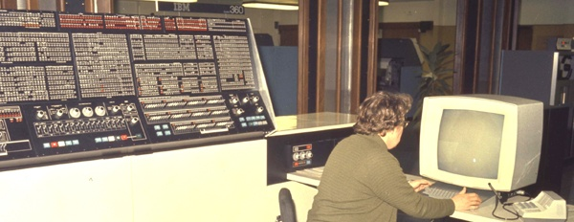

©UKRI Science and Technology Facilities Council, available from http://www.chilton-computing.org.uk/

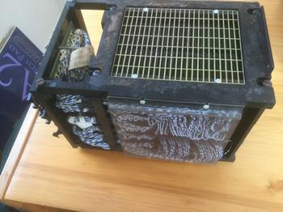 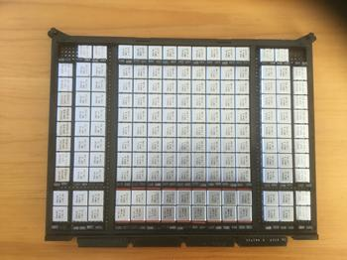

Core Storage Module Memory Cache Bit 0

Once the unidentified CE tool reported last time was received we were able to identify its purpose. One of the cassette tapes was labelled as a 3683 IML Backup. So it was used to load software into the 3683. The IBM 3683 was a cash till, announced late 1980 for shipment 3Q 1981, together with the IBM 3687 UPC code scanner and a separate print station. At the time of announcement, a checkout station with one 3683 and 3687 scanner together with three print stations was priced at $10,033. It could also be leased under a 5 year agreement for $320 per month.

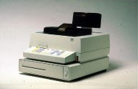 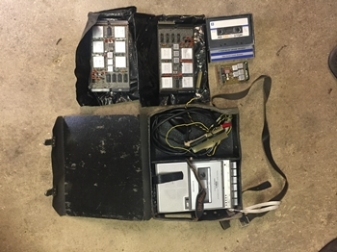   
IBM 3683 Previously unidentified CE Tool